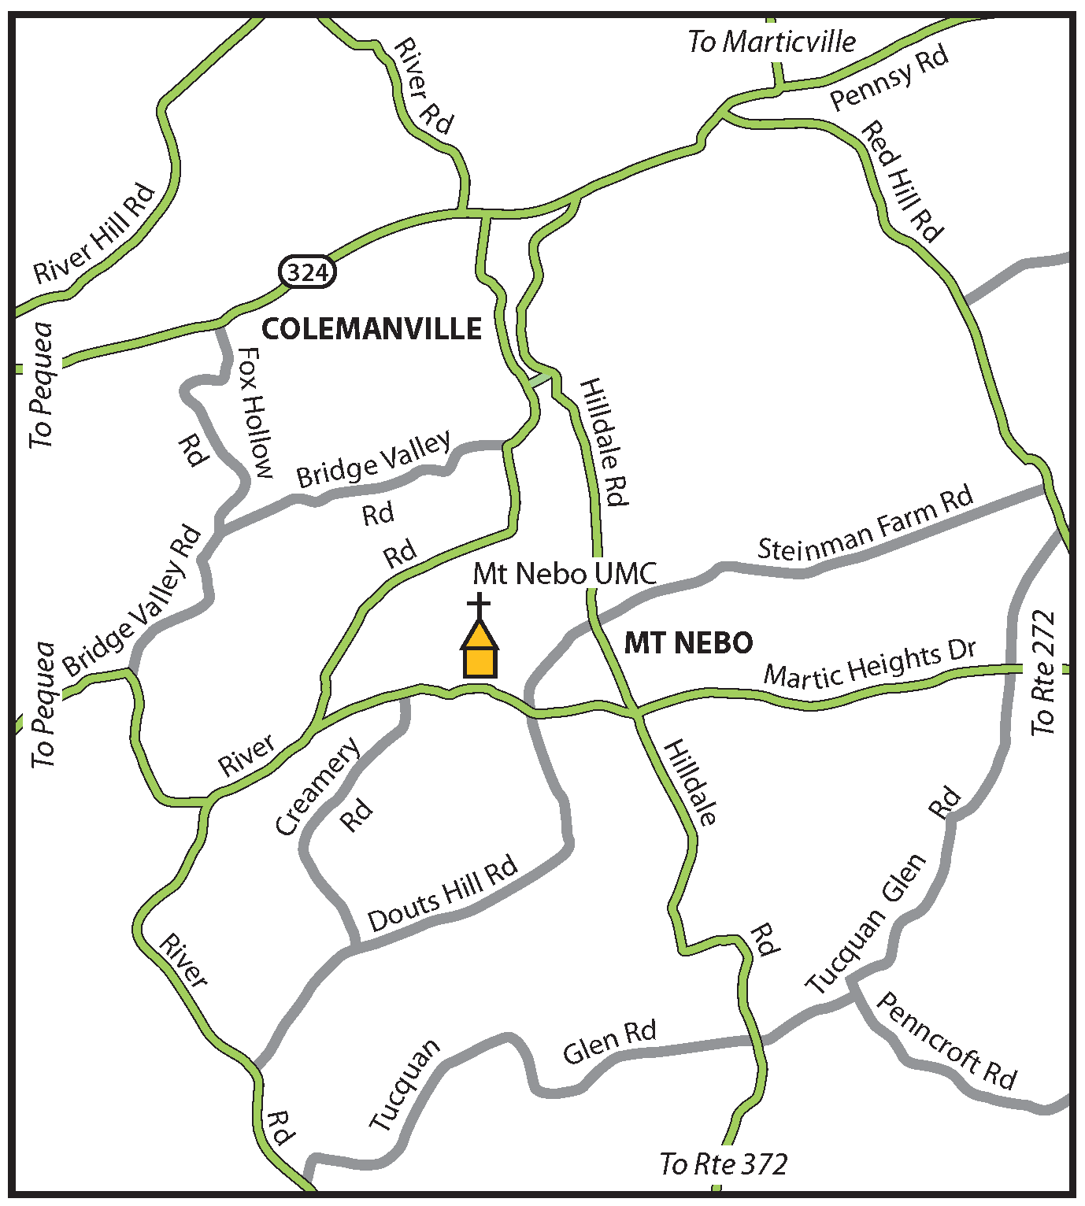

673 Martic Heights Drive
Pequea, PA 17565

MT. NEBO UMC PRESCHOOL HANDBOOK

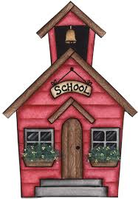

673 Martic Heights Drive
Pequea, PA 17565

Preschool: (717) 284-4441
Church Office: (717) 284-4331

Welcome

We are excited that you have chosen Mt. Nebo UMC Preschool for your child. We hope the school will provide a worthwhile and enjoyable experience for both you and your child.

Philosophy

A planned classroom helps children …

- Grow physically, emotionally, socially, and intellectually.
- Learn to work with others.
- Explore the world around them.
- Think of themselves as capable people.
- Grow in language.

Through preschool the children will …

- Grow through physical activities.
- Appreciate stories and books.
- Express themselves through art.
- Enjoy music.
- Learn to get along with others.
- Develop spiritual growth.

The preschool is conducted in a Christian atmosphere where the children can enjoy their learning experience through stories, crafts, activities, and supervised play. Biblical principles and examples will apply to all areas of the school curriculum. The school curriculum is aligned with the PA State Standards.

(Updated 3/5/21)
School Closing

In the event of inclement weather, the preschool will follow the Penn Manor School District schedule. If Penn Manor is operating on a one-hour delay, preschool classes will run from 10 a.m. to noon. If Penn Manor is on a two-hour delay, preschool classes will run from 11 a.m. to 1 p.m., and students should bring a packed lunch. Penn Manor cancellations are announced on local TV stations and radio stations, as well as on WGAL’s website.

The preschool is directed by the Mt. Nebo UMC Education Committee. The members of the preschool board for 2021-2022 are as follows:

Marie Snyder – chairperson
Mary Lynn Eggers – finance/registrar

Mt. Nebo UMC Pastor: Chandler Evans

“Train up a child in the way he should go and when he is old he will not depart from it.”
Proverbs 22:6

Examples of Structured Play

Dramatic Play: Through dramatic play, children are able to demonstrate the things they are learning and feeling about themselves and their world.

Block Building: Block building gives children a chance to think, plan, and solve problems while they work with their hands to develop fine motor skills.

Library: Children learn the value of reading through story times and borrowing library books.

Table Activities: Table activities allow children to practice problem-solving skills. Activities include stringing beads, working with puzzles, and playing with clay.

Art: Through paints, crayons, clay, paper, and paste, children are able to express their feelings and ideas.

Music: Children express themselves through movement to music while learning new rhythms and songs.

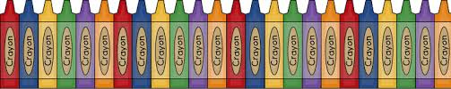

Arrival and Dismissal

School will begin at 9 a.m. and will end at 11:30 a.m. Please be prompt with both of these times. For safety reasons, we ask that you bring your child into the classroom and pick him or her up at the classroom. If someone other than the parent will be picking up your child, you must notify the teacher with a note. If you are going to be late for any reason, you need to contact someone to pick up your child at the end of the school day, or you may be charged extra for the teacher’s time.

Class Schedule

3-year-olds: Mondays and Wednesdays
4-year-olds: Mondays, Wednesdays, and Fridays

Admission/Enrollment

Children who are of class age by Sept. 1 of the current year will be eligible to enroll. Registration forms are available by contacting the church office at 284-4331.

Toilet Training

Children must be toilet trained before admission to preschool. Please have your child use the restroom before entering the classroom.

Clothing

Please have your child wear comfortable clothing suitable for both indoor and outdoor play activities.

Items from Home

Backpacks are recommended to carry papers, library books, and projects. Please do not allow your child to bring toys, money, gum, food, or other items without the teacher’s permission. Please clearly label all personal items.

Health Concerns

We recommend that your child have up-to-date immunization records. Please do not allow your child to come to school if he or she is ill. If your child becomes sick or injured, you will be contacted. If your child is on medications, please dispense the medications at home. We will NOT dispense medicine at school. Please inform the preschool teacher of any allergies your child may have.

Snacks

Snacks will be provided by the preschool.

Graduation

Preschool graduation will be held on a Sunday afternoon in May. The graduation date will be announced at a later time.

Tuition

3-year-olds: $600 per year or $150 per quarter
4-year-olds: $900 per year or $225 per quarter

Tuition is due quarterly in August, October, January, and March.

Please give payments to the teacher or mail payments to the following address:

Mt. Nebo UMC Preschool
673 Martic Heights Drive
Pequea, PA 17565

A $30 non-refundable registration fee must accompany your child’s registration form if the form is returned by May 31. Registrations made after June 1 must be accompanied by a $40 registration fee.

